Fairy

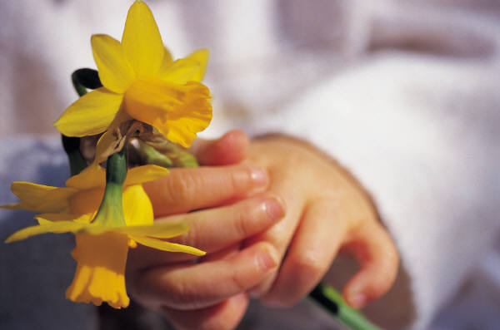
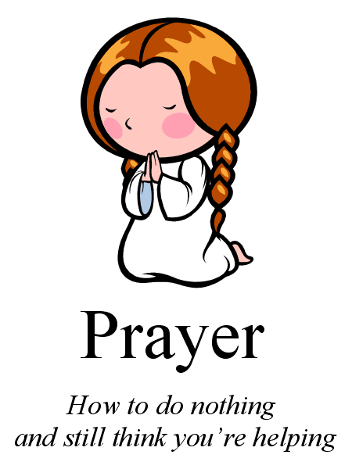

Colours
We are learning to mix all colours and how to recognise pastel colours and fluorescent
Colours.


spring

lent

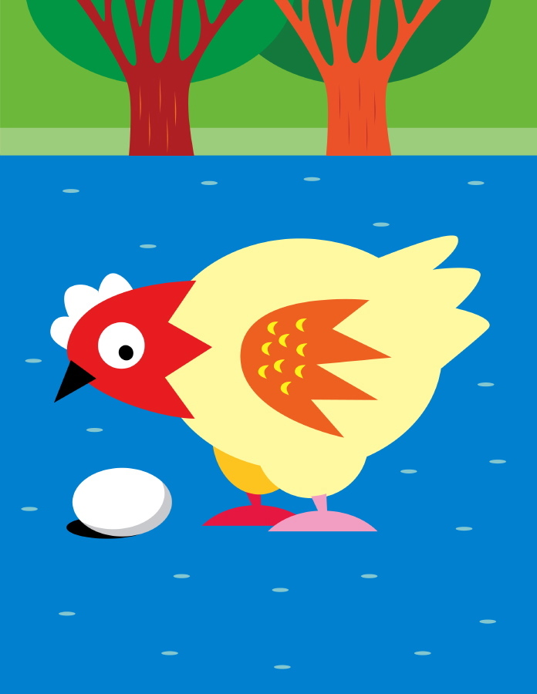
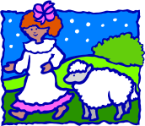


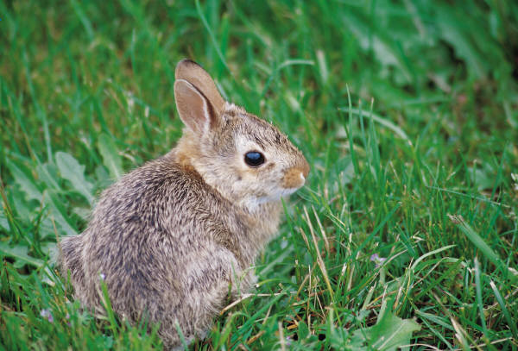

We are working together to prepare our garden for Spring


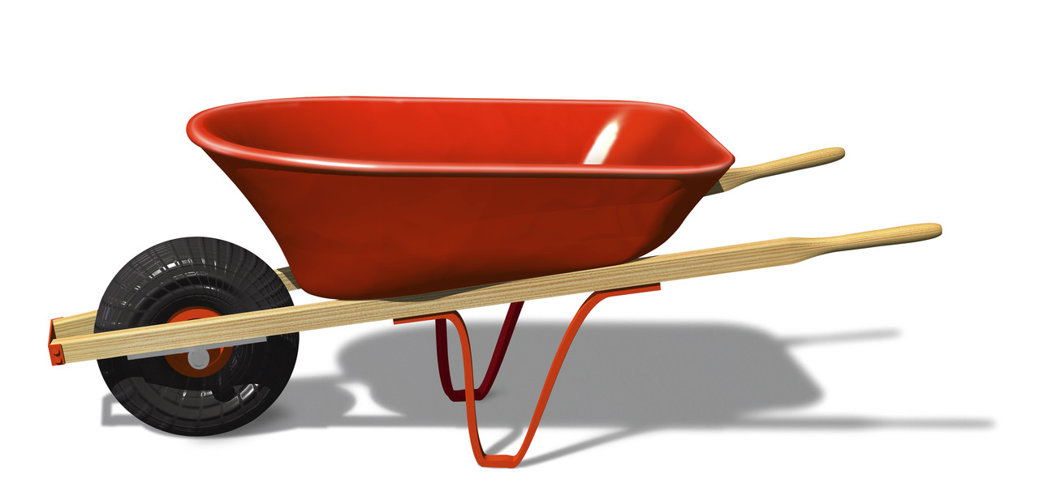

Chick,chick,chicken

Mary had a Little Lamb

Little Bo Peep

Little Bunny Froo Froo



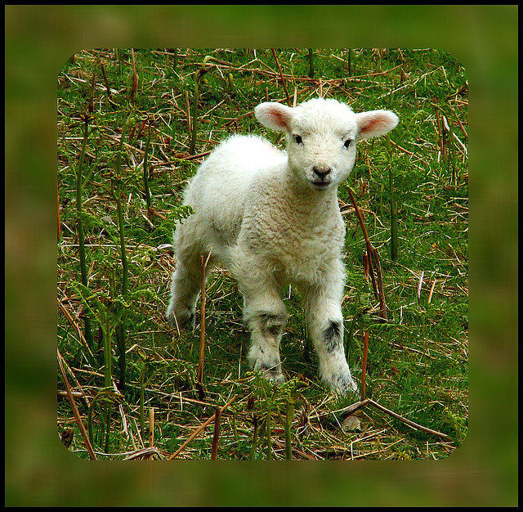

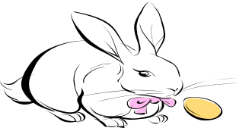





Spot’s First Easter

Mothering Sunday
19th March

Little Lamb

St Patricks Day 17th March

Little Rabbit




Drumshee Nursery
March Newsletter

Please ensure your child’s snack and dinner money is put into a bag or envelope with their name on it.

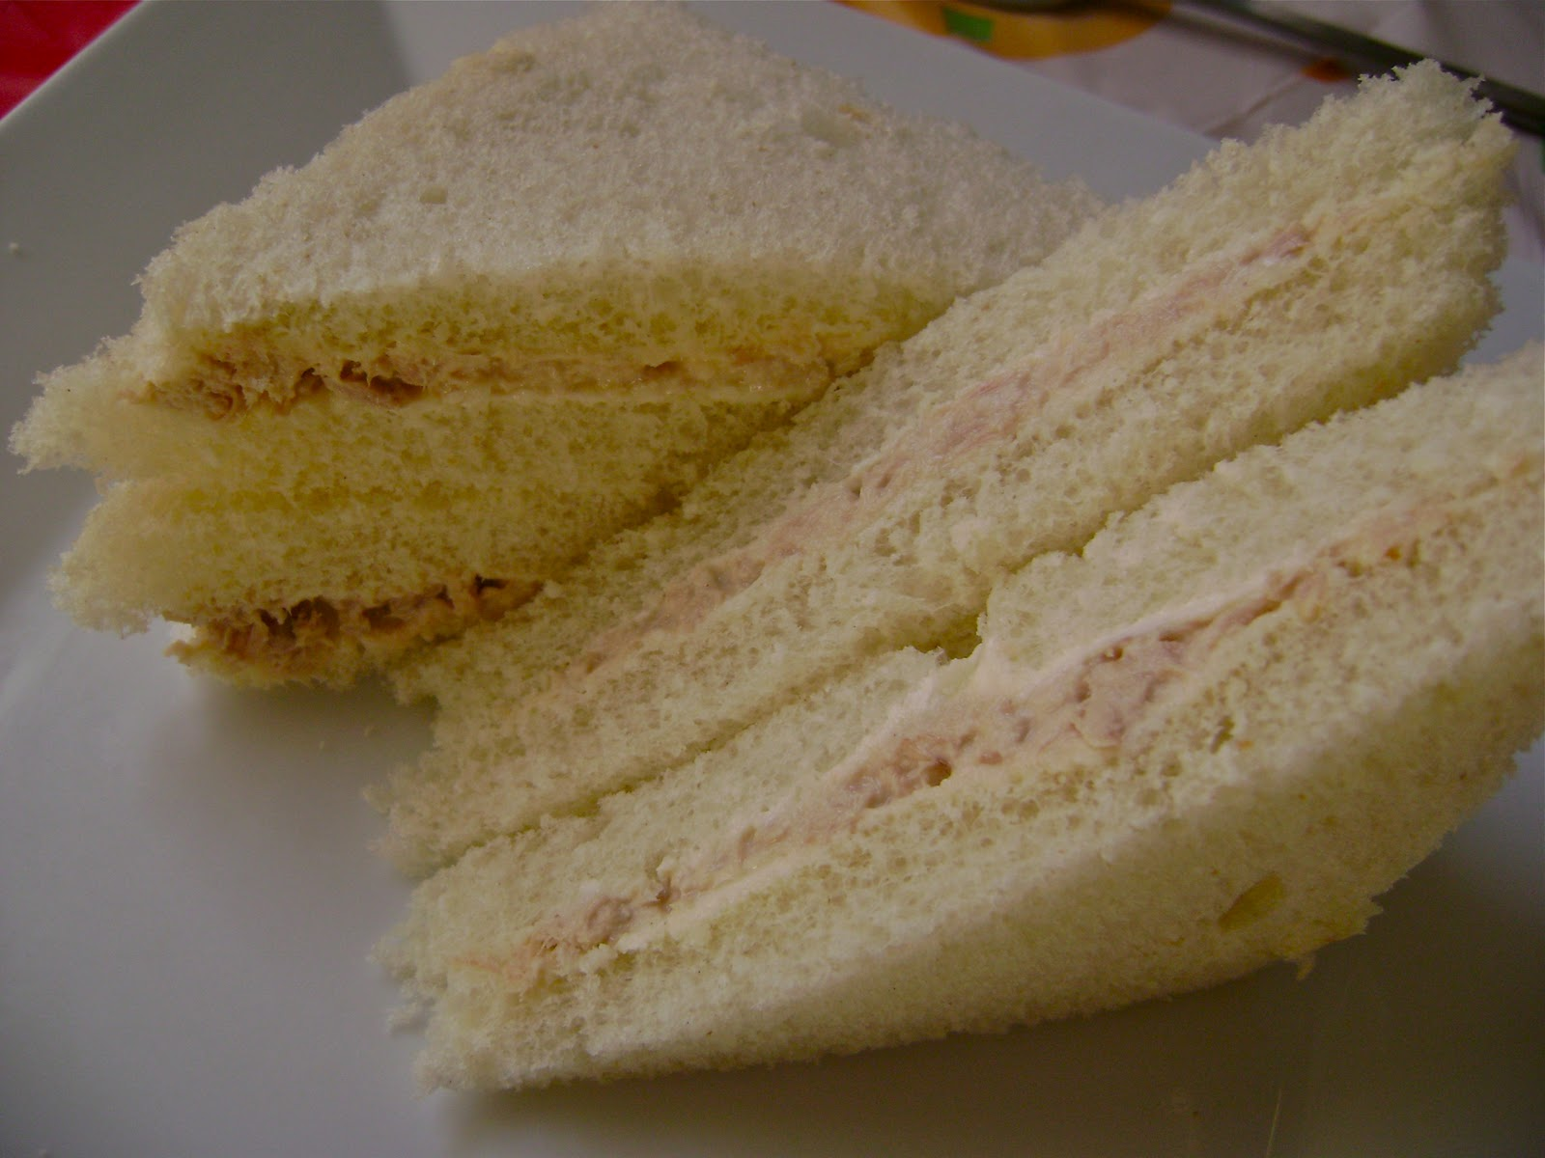
Please can you bring in empty boxes, empty cartons or any other pieces of junk.



Please cut up all sandwiches into four sections, it is easier for your child to eat.
Please cut grapes as they are a choking hazard

Please cut up sandwiches as it is easier for your child to eat/
Cut grapes as they are a choking hazard

March Calendar of events

Please encourage your child to put on and zip up their own coat.

MONDAY | TUESDAY | WEDNESDAY | THURSDAY | FRIDAY
 |  | 1st | 2nd | 3rd
6th   | 7th | 8th | 9th | 10th
13th | 14th | 15th | 16th | 17th
20th | 21st | 22nd | 23rd | 24th
27th | 28th | 29th | 30th | 31st

